Brute Force Partial Digest

**Algorithm 1:**

Write an algorithm that, given a set X, calculates the multiset ΔX of the complete digest and partial digest.

For example in partial digest, if X={0, 2, 4, 7, 10} then ΔX={2, 2, 3, 3, 4, 5, 6, 7, 8, 10} containing 5(5-1)/2 = 10 integers which are the ten pairwise distances between these points.

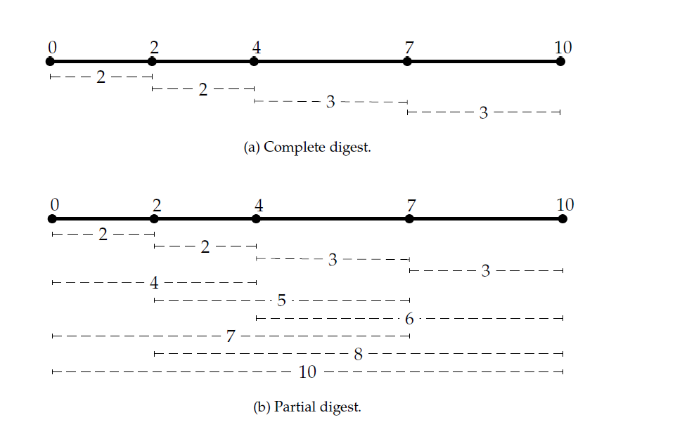

Algorithm 2:

**Goal:** Given all pairwise distances between points on a line, reconstruct the positions of those points

**Input:** The multiset of pairwise distances L, containing n(n-1)/2 integers

**Output:** A set X, of n integers, such that ∆ X = L

PartialDigest(*L*):

1. *width* 🡨 Maximum element in *L*
2. DELETE(*width*, *L*)
3. *X* 🡨 {0, *width*}
4. PLACE(*L*, *X*)

PLACE(*L*, *X*)

1. if *L* is empty
2. output *X*
3. return
4. *y* 🡨 maximum element in *L*
5. if **D**(*y*, *X* ) ⊆ *L*
6. Add *y* to *X* and remove lengths **D**(*y*, *X*) from *L*
7. PLACE(*L*, *X* )
8. Remove *y* from *X* and add lengths **D**(*y*, *X*) to *L*
9. if **D**(*width*-*y*, *X* ) ⊆ *L*
10. Add *width*-*y* to *X* and remove lengths **D**(*width*-*y*, *X*) from *L*
11. PLACE(*L*, *X*)
12. Remove *width*-*y* from *X* and add lengths **D**(*width*-*y*, *X* ) to *L*
13. return